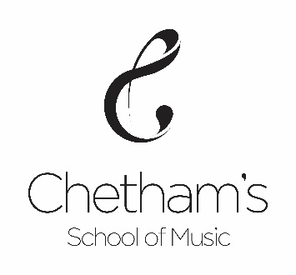

VACANCY

PRACTICE ASSISTANT
(Cello specialist)

Start date:
(subject to recruitment checks)

Hourly Rate: £13.80 per/hr

Hours: 5 hours per week

Chetham’s School of Music seeks an experienced musician to assist the students during practice whilst helping to reinforce the aims of the teacher

We are looking for people with the following credentials:

- Cello specialist Postgraduate or recent graduate
- Excellent musician
- Highly motivated
- Enthusiastic with young people
- Creative thinker

For an application pack and job description please go to www.chethams.com

Application deadline: 9am, Monday 4th November 2019

Interviews: w/c 11th November 2019

Chetham’s is committed to safeguarding and promoting the
welfare of children; applicants must be willing to undergo
child protection screening including checks with past employers
and the Disclosure and Barring Service. Reg. Charity No: 526702

