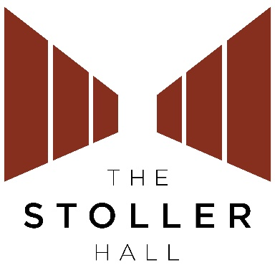

Access Form

Please complete this form, or answer the questions below by email, to register your access needs with The Stoller Hall. We will then be able to take these into account for all your future visits.
For assistance with this form:
Email Eleanor eleanorridley@chethams.com to receive the questions by email.
You can email the Box Office on boxoffice@chethams.com to provide your phone number and one of our Box Office staff will ring you back to complete the form with you.
Visit www.stollerhall.com/access for full details of our Access Scheme and how we can support you.
Please return the form to:
eleanorridley@chethams.com
Eleanor Ridley
The Stoller Hall
Chetham’s School of Music
Long Millgate
Manchester
M3 1SB

Your contact details
First name: _____________________________________

Second name: __________________________________

Postal address: _________________________________
______________________________________________

Postcode: _____________________________________

Email: _________________________________________

Your requirements
Do you require (circle or delete as appropriate):
A free seat for an essential companion? Yes / No

A wheelchair space? Yes / No

If yes, would you prefer to remain in your wheelchair, or transfer into a seat?

A space for an assistance animal? Yes / No

Please use the space below to give us any further details of your support needs:

Please confirm that you are happy for us to record this information for any future bookings at The Stoller Hall. Yes / No

